Lab 2: Containerization & Kubernetes Orchestration
Task 4 — Docker Network
1)Two containers communicating through a Docker network
2)Communication using container names and container IP addresses.
Create the Docker network
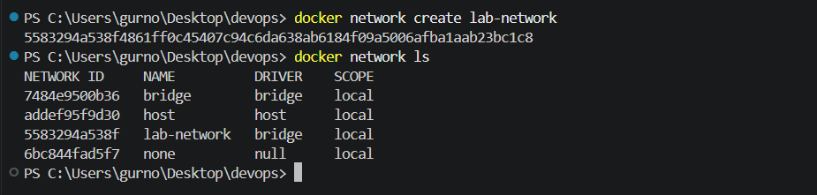
Start two containers on the network
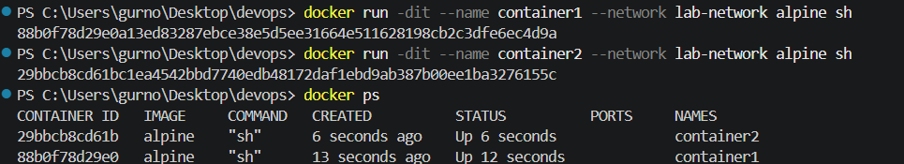

Communicate using container names
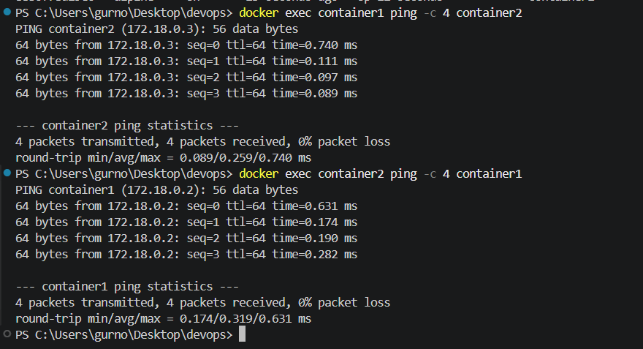

Find container IP addresses
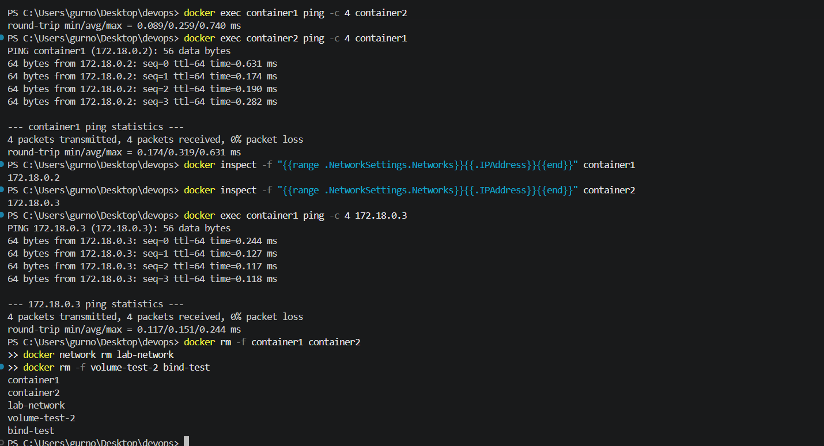
Result: A custom Docker bridge network was successfully created. Two Docker containers were connected to the network and successfully communicated using both container names and container IP addresses. Docker's internal DNS allowed containers on the same custom network to resolve each other by name.

